**Form Layouts**

**1. Main Screen**

**2. Help Screen**

**3. Change Unavailable**

**4. Breakdown of Change Screen**

**5. Login Screen**

**6. Manager Screen**

**7. Report Screen**

**Main Screen**

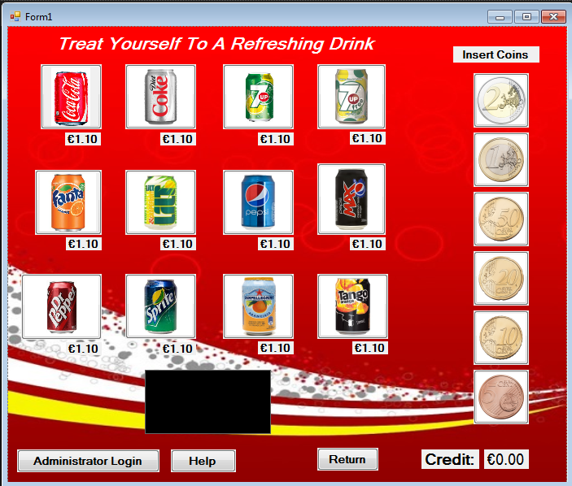

**Help Screen**

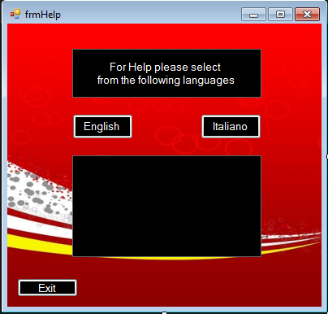

**Change Unavailable Screen**

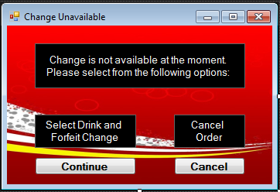

**Breakdown of Change Screen**

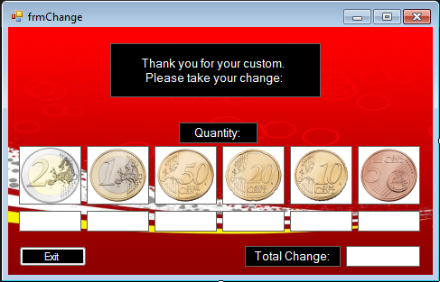

**Login Screen**

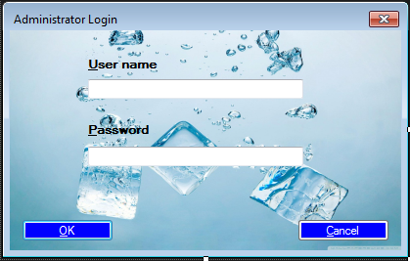

**Manager Screen**

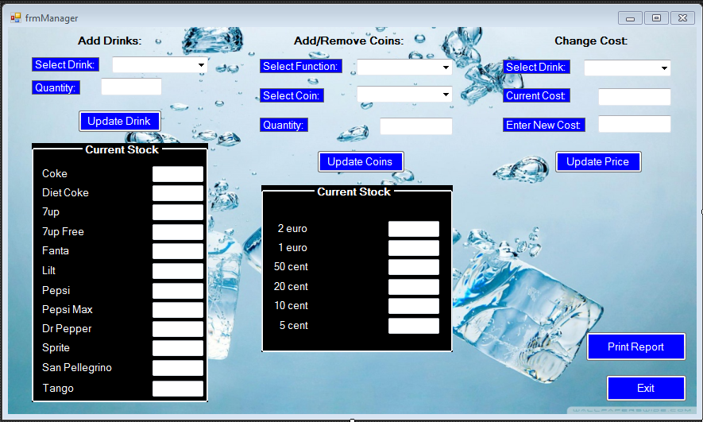

**Report Screen**

